E();



**Reynoldsburg Lodge #340**

**7350 Broadwyn Drive**

**Reynoldsburg, Ohio 43068**

**(614) 866-8179**

**Stated Meetings:**

**First and Third Tuesdays**

**7:30 PM**

**Special Meetings:**

**As called by WM**

**Lodge Officers:**

**Worshipful Master**  Derek Martin

[wm@mason340.com](mailto:wm@mason340.com) 614-747-5150

**Senior Warden**  Alex Jackson

[sw@mason340.com](mailto:sw@mason340.com) 614-371-1424

**Junior Warden** John Wronski, PM

[jw@mason340.com](mailto:jw@mason340.com) 614-861-3883

**Secretary** Gary Wehr, PM

secy@mason340.com 614-202-1523

**Treasurer** Buck Boyd

treas@mason340.com 614-759-4398

**LEO**  Charles Ashley

[leo@mason340.com](mailto:leo@mason340.com) 614-861-3425

**Trestleboard Editor** Gary Wehr

tb@mason340.com

**Web Editor** Ken Cohen

Ken.Cohen@mason340.com 614-577-0017

**Next Trestleboard Deadline**: March 10,2014

**Website:** <http://www.mason340.com>

***Mark Your Calendars!***

**C:\Documents and Settings\gxw027\Local Settings\Temporary Internet Files\Content.IE5\DTU7LITY\MC900410407[1].wmfFebruary 2014 -**

4th – Reynoldsburg’s Stated Meeting 7:30pm   
 **WILD GAME** Dinner 6:30pm

6th – Inspection 7:00pm   
Dinner 6:15pm

11th –Whitehall 761- Stated Meeting 7:30pm

18th -Reynoldsburg’s Stated Meeting 7:30pm  
Dinner 6:30pm

18th –Eugene Chapter’s Social Club 1pm

22th –Reynoldsburg’s Monthly Breakfast 8-11am

25th –Whitehall 761 Stated Meeting 7:00 pm

**March 2014 -**

4th –Reynoldsburg’s Stated meeting 7:30pm  
Dinner 6:30pm

8st – Grand Master’s Reception at Villa Milano’s

11th -Whitehall’s Stated Meeting 7:30pm

12th – Eugenie Chapter’s Stated Meeting 7:30pm

18th -Reynoldsburg‘s Stated meeting 7:30pm  
Dinner 6:30pm

25th – Whitehall’s Stated Meeting 7:00pm  
WHITEHALL’S INSPECTION – EA DEGREE

29th –Reynoldsburg’s Monthly Breakfast 8-11am

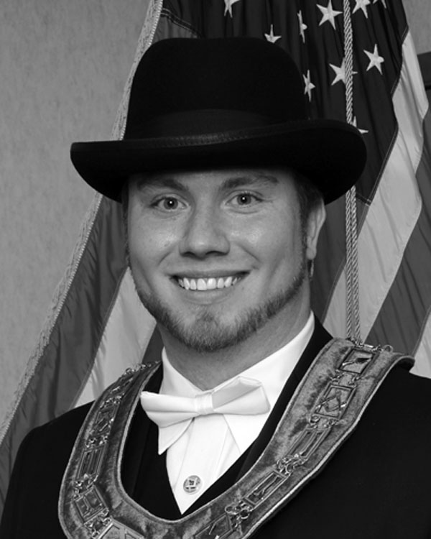From the East Derek Martin, WM

I hope everyone had a fun and safe holiday season!   
As we venture into 2014, inspection season has already kicked off. I want to encourage everyone to attend one or all of the inspections. It is a great way to meet other brothers around the district and bring helpful suggestions back to Reynoldsburg.

I want to make sure everyone knows that our inspection is set for Thursday February 6th, Dinner is at 6:15 pm, the FC degree will start at 7pm. Please come out and support your officers as they give an excellent portrayal of the degree! (For a complete list of inspection dates and times, please see the 14th District website).   
  
To reference one topic I spoke about at the last meeting, after our inspection has passed there is a sigh of relief among the officers and Master! So starting mid-February, I would like to find out what YOU, the membership would like to do at the meetings? Do you enjoy education programs, fun activities/ games? Or has it been 35 or more years since you have received a degree; and maybe you would like to relive that experience? This is your lodge and not everyone enjoys just a quick business meeting and degree work when we have it. I want lodge to be a place that you look forward to coming to, and hate to have to go back home. I encourage everyone to let me or another officer what they would like to "do" at lodge.   
  
Also, we need to make sure we sign up early and often for fundraising events where we can get our funnel cake set up and start generating revenue. We as a lodge decided that this was going to be our main focus for a fund raiser. Please be sure to get in contact with the Stewards. They will be the coordinating the staff for our fundraising events.   
  
Lastly, I want to make sure everyone is aware of the following important dates:

**02/04/2014: Wild game night   
02/06/2014: Reynoldsburg Inspection.   
02/27/2014: 14th District Meeting.   
03/08/2014: Grand Master's Reception (Before 02/15 $38.00 per person, after $45.00 per person)   
04/05/2014: Grand Master's Class (March 15 petition deadline).**

From the West Alex Jackson, SW

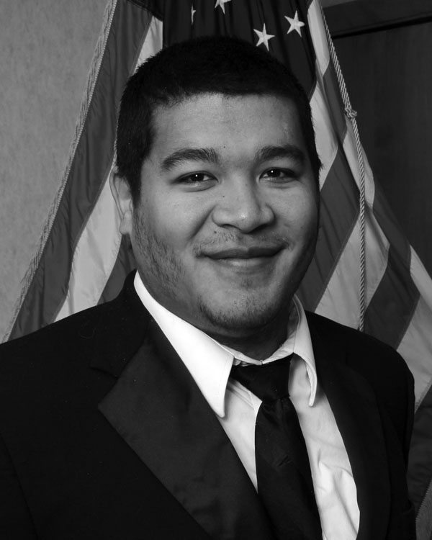My Brethren, traveling season is upon us. And no, I don’t mean run south of the Mason-Dixon and avoid the snow. By traveling season I refer to what is better known as “Inspection Season.” Yes it is that time again and it is a glorious time to be a Master Mason. As most of us know each year every Lodge under the Grand Lodge of Ohio must perform a degree to be inspected upon. Yes, this may be a bit stressful for the officers but more than anything it is an opportunity for the Craftsmen themselves. In our district alone we have 26 Blue Lodges. This affords the membership the chance to meet new Brethren (hint to the newest members), connect with old friends and enjoy degree work in all its glory.

For those who gripe, “I’ve seen this degree a hundred times!” must remember that each Lodge is as unique as its membership. Some Lodges light candles, crank up the ambiance and give you a multi-faceted sensory experience. While others keep it simple and precise, perfectly squaring corners and delivering dramatic pauses that would make most nod in agreement at the well thought delivery. Doesn’t each of these Lodges deserve the support that we ourselves want when it comes to our beloved Lodge.

Maybe you can only make it to our own inspection, February 6, 2014 at 7 P.M. to which we would love to see you. Or you can make it to all of them, as Brother JD Jim Woodward did last year. But whatever you can do know that your presence it greatly welcome and your show of Brotherly Love does not go unappreciated.

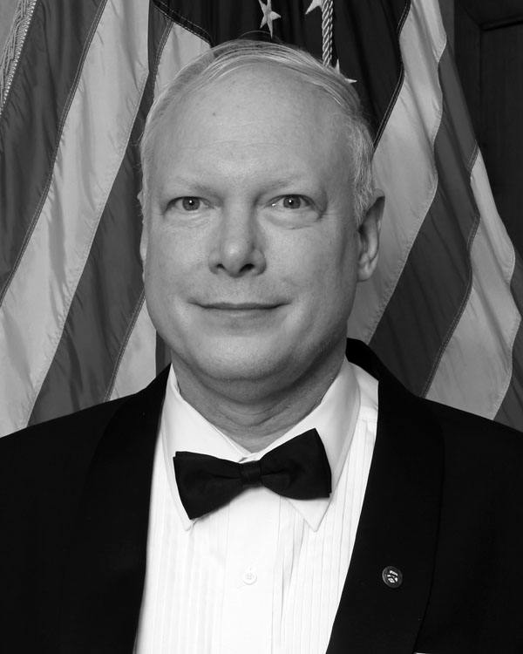From the South John Wronski,PM

The other day I was contemplating the various brethren who need to be introduced at the annual inspection and asked myself, “Who are the most important brethren in the lodge?” Let's start by reviewing several categories of possibilities.

The Worshipful Master is important; his very title denotes the respect due him. He sets the tenor for his year, governs the lodge most of the time and delegates responsibility on occasion. Without this leadership, the lodge would probably degenerate to chaos. Even Past Masters are introduced to recognize their experiences in that chair and continues to be addressed as Worshipful.

The lodge's Secretary and Treasurer are also vital in preventing chaos. Much of their efforts take place outside of lodge meetings and may go largely unheralded.

At every lodge meeting brethren with twenty-five or more years of membership are introduced and thanked for their part in keeping the lodge in existence.

At the annual inspection, other distinguished Masons are also introduced. They may or may not be members of the particular lodge being inspected. The Grand Master, Grand Officers, District Deputies, District Education Officers, District Association Officers, Knights of the York Cross of Honor and 33rd Degree Masons are among the categories that come to mind. These brethren are respected for their leadership to bodies with broader ranges than the lodge.

Although brethren in the categories mentioned above are important to the lodge for the reasons stated, I believe the most important brethren are the Entered Apprentices who have not yet been passed to Fellow Craft. They represent the future of any lodge. At this point in their Masonic lives, they have nothing but potential for success or failure. Hopefully they will continue to participate in lodge activities. They may, perhaps someday, fit into one more of the categories above. On the other hand, they may become bored and drop out. Therefore, it is vital to nurture good Masonic practices among these newer brethren. So, when you are shaking hands before or after meetings, be sure to shake their hands as well.

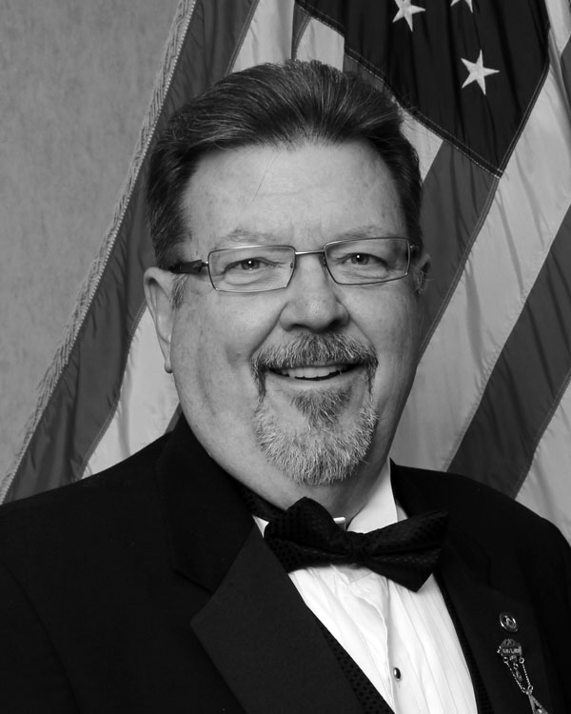From the Secretary Gary Wehr, PM   
My article for this issue addresses communication. We have recently experienced some really, really cold weather. The weather that was too cold for some members to venture out to attend Lodge. If the weather gets to a point where the Worshipful Master decides to call off a meeting, I will put out an automated phone blast letting you know. In the past, I have used this method of communication to let you know about funerals and most recently about Breakfast with Santa. If you live locally and never received a phone message like this, then I don’t have your phone number. Communication is a two way street. You need to provide me with a current phone number. A current email address would be great too! So if you want to know what’s happening in Lodge, get me a phone number and/or email address. Also, if you know a Brother that isn’t feeling well, in the hospital or needs a ride to Lodge, etc., let one of the officers know and we’ll get in touch with the member. All of the officer’s phone numbers and email addresses are listed in the Trestleboard. We need you to communicate with us as much as we need to communicate with you!

You know, I really enjoy being the Secretary of this Lodge. I admit, I have made some mistakes in the past, and I will make mistakes in the future. I am not perfect. I recently mailed out about 30 Dues Notices for the 3rd time. I made a mistake and mailed one to a member that had the same last name as a Brother that should have received the notice. I called to apologize and explain my error. So if this ever happens to you, hopefully it won’t, just give me a call and I’ll get it straighten out.

Want to help out the Lodge but you live far away and can’t attend? Well do I have an offer for you! If you have a good working knowledge of Microsoft Word and would like to become the editor of the Trestle-board, it would be greatly appreciated by many, especially me! I took it on because we didn’t have anyone else at the time. I’m a novice when it comes to Word and I use the assistance of WB Ken Cohen on each issue. This is something that could be done long distance, over the internet. If you would like to give it a try, just let me know. I can send you some sample articles and the template for you to experiment with. Who knows, you might come up with a better looking issue! If you don’t know how to do this, maybe your wife would like to give it a shot!

If this sounds like something you would like to do for your Lodge, please let me know. Email me at [secy@mason340.com](mailto:secy@mason340.com) or call me (614) 833-1785 if you want more details.

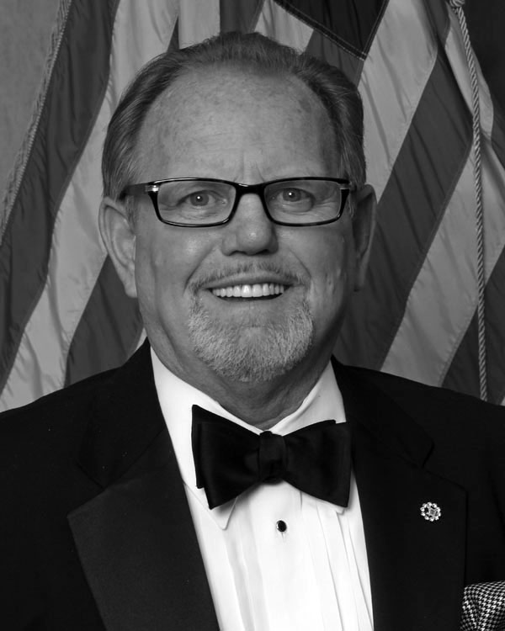

From the Treasurer   
Bro Buck Boyd

Brethren, with the current year a quarter of the way though, it’s important that we use the upcoming months to insure a financially successful year. We have the means to do this with the funnel cake machine and equipment. We are putting our applications in to many upcoming festivals and events around the city and counties. Your help is vital. By assisting with manning the booth, we can make sure no one will work long hours and days. We have invested a lot in this endeavor and hope to end the year with a substantial increase in our savings and operational accounts, as well as meeting our charitable obligations. We will be printing a calendar with the times, dates and locations for this summer’s events. If you can help, please call and sign up. It will be a lot of fun as well as a great help to your Lodge.

To all of you retired brethren…. we are going to try something new – a Retiree Club. The only qualification to become a member is that you are retired and want to enjoy some good fellowship. You never know, we might even think of some ways of helping the Lodge as a group. We’ll enjoy each other’s company, reminisce about the “good old days” and see what develops! We can play some cards or what- ever the group wants to do. This is an opportunity to get back to Lodge without the worry of being obligated to work – just have fun.

Speaking of the good old days, if any of you have Lodge memorabilia i.e. programs, pictures, awards etc. that you would like to share with the Lodge, please contact me. Watch for further details in the next issue. We are trying to start a museum as well as put together a Lodge history. All items submitted will be returned upon request. We will make copies of pictures and other printed materials.

We thank each of you for your support for each of these important endeavors of your Lodge. 340 is growing! Come to a meeting and find out how exciting the Lodge and brethren can be!

Master Craftsman Program  
Bro Charles Ashley, LEO

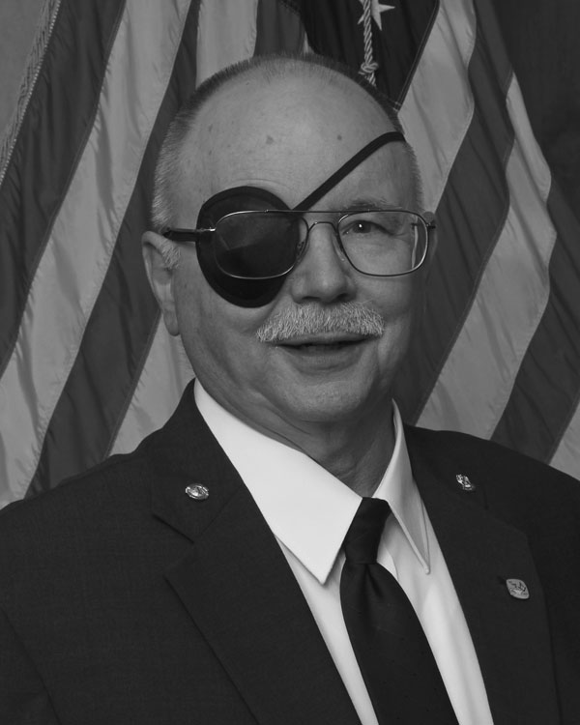Masonic education is the keystone that unlocks all things Masonic into a unified whole. The love of Masonry and enthusiasm makes for a vibrant and robust Lodge. The Master Craftsman (MC) Program is designed to meet this challenge. The MC program is both similar and very different than our previous Candidate Counseling Program. It has been expanded to include not only the traditional ritual work and education but the continued education of the new Master Mason.

To this end, a new Education Team has formed. Your team is comprised of the LEO, Charley Ashley and Brothers Brad Love PM, Gary Wehr PM and Ken Cohen PM. The team reviewed the old and new education systems. We are great on ritual preparation and basic education but we are short on education for the Grand Master’s Class MMs (one day), the newly minted MMs and we need better training for our traditional apprentices. Brother Love has stepped up and will be in charge of the Education of both Grand Master Class MMs and selected traditional candidates. He will be conducting seminars and classes for each level - EA, FC, and Master Mason. Traditional candidates will be able to attend their appropriate seminar level - EA, FC and MM along with their MCs.

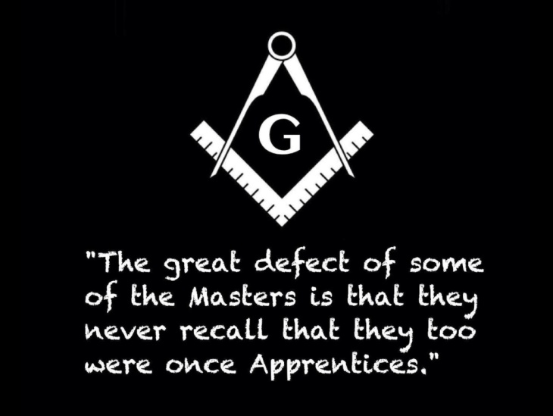The Master Craftsman program will be re-introduced to the lodge and we will formally establish a cadre of Master Craftsman. Both initial and ongoing training seminars will be conducted. We will establish a better educational tracking and training system. Seminar times, dates and locations to follow.

Stay Tuned!!!

Rent the Lodge  
Got a big family gathering? Office party?  
Rent Godfrey Hall for your function  
Just $50 to rent Godfrey Hall   
for members of   
Reynoldsburg Lodge, Whitehall Lodge or Eugenie Chapter  
Only $75 for non-members  
Additional Charge for kitchen use  
Contact WM Derek Martin   
at 614-747-5150 for details

**C:\Users\CohenK5777\AppData\Local\Microsoft\Windows\Temporary Internet Files\Content.IE5\WF2W6V98\MC900356157[1].wmfJoin us on February 4**

**Stated Meeting at 7:30**

**Wild Game Dinner at 6:30**

**Bring a dish to share,If you don’t hunt, bring some wild salad or wild rice-a-roni**

**NO TIES ALLOWED**

**REYNOLDSBURG LODGE INSPECTION**

**Thursday, February 6, 2014**

**Dinner at 6:15PM**

**Lodge at 7:00PM**

**FELLOWCRAFT DEGREE**

Please help us have a good attendance from our members.

**WHITEHALL LODGE INSPECTION**

**Tuesday, March 25, 2014**

**Dinner at 6:15pm**

**Lodge at 7:00pm**

**ENTERED APPRENTICE DEGREE**

The lodge with the most members in attendance wins the traveling gavel. Help our lodge have a good showing for our sister lodge and win the gavel.

[Photo: As I sit here thinking, I would like to thank all the men and women that have served and are currently serving for the freedoms I have each and every day.
One of the Admins.](https://www.facebook.com/photo.php?fbid=10152168813109349&set=a.402532469348.177640.348178979348&type=1&relevant_count=1)[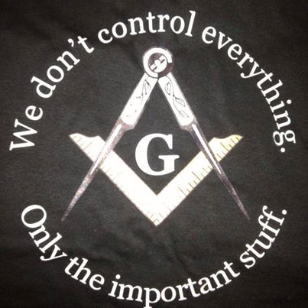](https://www.facebook.com/photo.php?fbid=10152154051129349&set=a.10151646015794349.1073741824.348178979348&type=1&relevant_count=1)

**Reynoldsburg #340 Rookie Award**

This award shall be given to any MM who, within a year from his raising, completes 4 of the Elective tasks and all of the required tasks. Any tasks completed before the 3rd degree will still count towards the tally.

**Required**

* Attend one conferral of each degree after you receive it
* Attend one inspection outside of your home Lodge
* Attend home Lodge's inspection
* Assist with one breakfast (cooking, serving or clean-up)
* Help with Trustee's Clean Up Day

**Elective**

* Attend one "Officer's Meeting"
* Attend one Masonic Funeral
* Serve on an Investigation Committee
* Sponsor a candidate for membership
* Perform a part in the MM degree (speaking or non)
* Assist with one Lodge event or fundraiser
* Assist once with setting up the Lodge
* Assist once with the preparation of a candidate
* Attend at least seven stated meetings at home Lodge
* Mentor one candidate in the degree proficiency

This isn’t a competition with anyone but yourself. Every new member can earn the Rookie of the Year Award. Show your enthusiasm for your new lodge by taking part in this program.

**Helping Jack Become Masonry**

Note: This is the third installment in the series Becoming Masonry

by Mike Clevenger, PM New England #4

It has been two weeks since John attended Jack’s EA degree and asked permission to mentor him. John has been busy with work but set aside time to assemble the materials that he will use to begin Jack’s Masonic education.

John will use his Lodge’s Masonic personal development template and manual entitled Becoming Masonry.This manual was developed to be used after the Entered Apprentice degree to help a Brother affirm and assess his beliefs, write a personal values and mission statement and then develop a comprehensive personal development plan that the Brother will follow. This plan will include goals, strategies, and specific action plans for five areas of his life; personal, relationships, Masonic, professional and community.

As Jack progresses through the Fellowcraft and Mason Mason degrees, John will provide assistance in understanding the lessons presented and then integrate them into Jack’s life plan.

Jack had agreed to meet John for breakfast at a local restaurant to map out a plan for Jack’s Masonic education. Jack wasn’t too sure what all they would discuss so he had asked his Uncle Ted what to expect. Ted told him that all they were going to do was begin working on the Entered Apprentice exam that Jack would have to present in Lodge.

John was waiting when Jack arrived at the restaurant. Jack saw him sitting in a booth in the back corner of the dining room. At first Jack thought it odd that he was the only person in that area, then he remembered what his Uncle told him the purpose of the meeting was, so he assumed that John was there so no one could hear their conversation about  the “Masonic Secrets” he was about to hear.

They both greeted each other, the waitress came and took their breakfast orders and then John looked at Jack and said, “Jack, what is your plan for your life?” Jack didn’t know what to say. He hadn’t been expecting that question at all. Matter of fact no one had ever asked him that.

Finally Jack was able to mumble, “well, ugh, I don’t know what you mean.”

[](http://www.masonicleader.com/wp-content/uploads/2013/08/masonic-man-mirror.jpg)John knew from his experiences with other new Brothers that this was a typical response. So he said, “Jack, I know you’re just 23, but I’m sure you’ve thought something about your future; haven’t you?”

“Well sure,” Jack said, “I hope to have a lot of friends, be married someday, and have a successful career doing something I love to do.”

“So you do have plan,” said John.

“Well sure, I guess I do; maybe right now I would call it a few dreams,” Jack replied.

“You are right Jack, because that’s just what they are; dreams, just dreams,” mused John. John let his words sink in a bit with Jack and then asked, “Jack why do think we are meeting here today?”

“Well, I wasn’t sure what we would talk about so I asked Uncle Ted and he told me we were going to work on the EA exam I have to take; that’s right isn’t it?”

“That’s right, it’s partly the reason,” replied John. “Jack have you heard the phrase Masonry takes good men and makes them better?”

“Sure, my Uncle Ted told me that’s Masonry’s purpose.”

“Did Ted tell you how Masonry makes you a better man?”

“Sure, he said that Masonry consists of three degrees and each one teaches different lessons that a Mason can use in his life,” Jack was proud of himself that he remembered but beyond knowing what his Uncle told him he didn’t have a clue how he would use the lessons in his life. Matter of fact, thinking back to the Entered Apprentice degree he just experienced, he didn’t have a clue what the lessons were he had just been taught.

“So, let me recap our conversation so you can get to work. You have some dreams for your life but not a definite plan to accomplish them, you know that Masonry is supposed to make you a better man, and it does that by teaching you lessons in three degrees you can use in your life. Does that pretty much sum it up?” Jack nodded that it did.

“Let me ask you one final question Jack; what lessons did you learn in the Entered Apprentice degree?”

Just like the first question John had asked, Jack had no immediate answer. He remembered some things about the degree but not enough to understand what happened, let alone know what lessons had been conveyed. John knew what Jack was thinking because he had asked the question many times to new Brothers and recognized the somewhat panicked look he generally received.

“Look Jack, I know you’re probably thinking that you just flunked your first test as an Entered Apprentice. Don’t worry that’s not the case at all. I wanted to impress upon you that the degrees of Masonry are presented to you and then to understand their meaning you need to study them. That’s where I come in; my job is to help you do that.”

“Are you busy next Tuesday evening?” asked John. Jack said he wasn’t and John went on, “Good. I want you to experience the Entered Apprentice degree again; this time at my Lodge with my guidance. Here is a fact sheet with some of the key lessons presented in the degree and a series of questions that I will be asking you to answer once you have seen the degree again.”

“Our Lodge begins here in the banquet room at 6:00pm. I want you to be my guest for dinner, meet some of the Brethren of my Lodge and then we will move to the Lodge and witness the bringing first light to a candidate. After the degree we will talk briefly about a meeting time for your next step in your Masonic education. Oh, by the way, the dress is coat and tie.”

Jack left the restaurant wondering if he could concentrate on work now. John’s questions had surprised him. A plan for his life; what did Masonry have to do with that? As he walked to his car he glanced at the sheet John had given him. A lot of probing questions, many of them Jack had never asked himself before. Then he remembered that John had never said a word about the stuff he had to memorize. Jack pulled out his mobile phone and made a note in the folder he created called “Masonry.” He would ask John Tuesday.



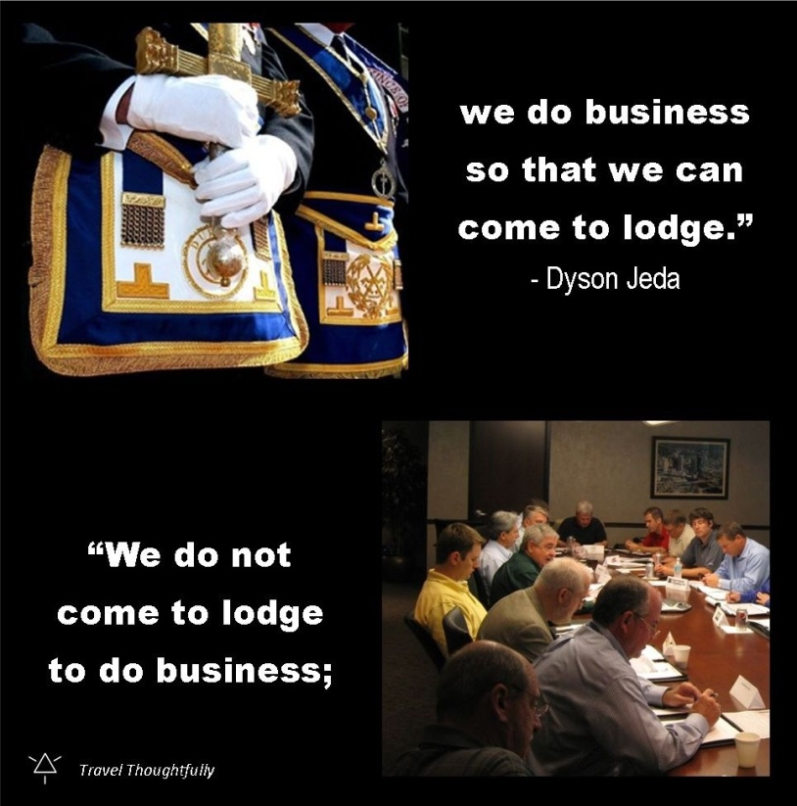



**February**

8 Dan Hill

11 Forest Paxson

11 James Moeckel

12 John Wronski, PM

12 Donald Whybrew

13 William Peters, PM

14 James Myers

17 Donald Filmer

18 Donald Weilbacher

18 Michael Myers

18 John Trikouros

21 Dave Klawitter, PM

22 James Matthews

22 Brian Quales

23 Robert Mullenax

23 Harold Elliott, PM

23 Lloyd “Skip” Degonia, PM

23 Edward Rutherford

23 Daniel Ellis

24 Richard McKinney

24 Brandon Hutchinsl

24 Harold Wesley

24 Chris Diaz

27 John Brogan

28 William Mills

28 John Pinkerton

28 Kevin Slone



**March**

1 Steven Reindel  
5 Jerry Few

5 Melvin Hanley

6 James Glaze

7 James Audet, PM

9 Clarence Ransburgh

9 Robert Springer

9 Monroe Bradley

11 Louis Melmige

11 John Schaeffer

16 James French

17 Andrew Mesaros

20 Richard Basye

20 Scott Edgel

20 Davy Moore

22 Stanley Gatterdam

25 Bradley Arnold

28 Gary Wehr,PM

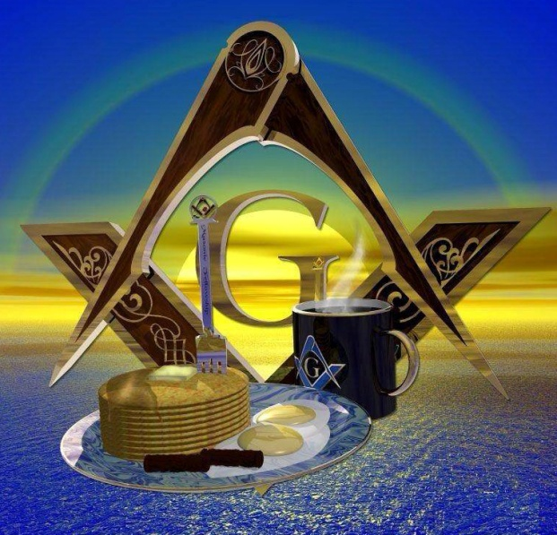

**Don’t forget our monthly breakfast on the   
Saturday of EVERY month, 8-11am. All you can eat for $6.**

Please support OUR SPONSORS

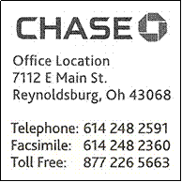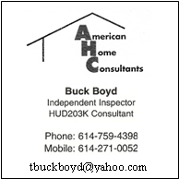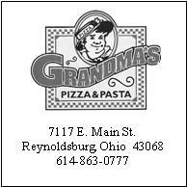

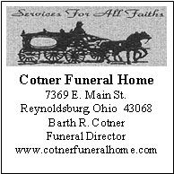



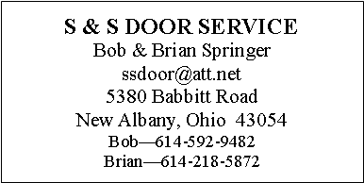

Please support OUR SPONSORS

[](http://www.google.com/url?sa=i&rct=j&q=&esrc=s&frm=1&source=images&cd=&cad=rja&docid=qC9MotqY53XYYM&tbnid=W2vq0nQPmWpd3M:&ved=0CAUQjRw&url=http://theupiafiles.wordpress.com/2011/04/17/i-am-a-freemason/&ei=K4w6UaeVB-Xp0AHg0YGoDg&bvm=bv.43287494,d.dmQ&psig=AFQjCNHGurslu-Gg3ElBFY_CpbL3nZVgyA&ust=1362877607056919)

P.O. Box 624

Reynoldsburg Lodge #340 F&AM

Reynoldsburg, OH 43068

DATED MATERIAL – PLEASE DO NOT DELAY

NON-PROFIT ORGANIZATION  
U.S. POSTAGE PAID  
PERMIT NO. 30  
REYNOLDSBURG, OHIO 43068